COMPARATIVE STUDY OF OXIDATIVE STABILITY OF BIODIESEL FROM OIL AND BABASSU COCONUT OLIVE OIL

João Ferreira da Silva Neto, Jose da Silva Machado¹, Fernando Mendes^{, , e} , Ana Angélica Mathias Macêdo¹, Claucia Fernanda Volken de Souza

Abstract
Our aim was to produce biodiesel from babassu coconut oil and olive oil (Orbignya speciosa Mart.), fulfilling the National Petroleum, Natural Gas and Biofuels Agency (ANP) parameters to be used vehicles and diesel cycle engines as fuel. The continuous increase in world population causes the growth in energy demand, generated mainly by non-renewable, fossil and non-biodegradable sources, which contributes to the increase of global pollution. Therefore, the use of renewable, biodegradable and non-toxic energy sources, such as oil and olive oil of babassu coconut (Orbignya speciosa Mart.) has both economic and environmental advantages. Babassu coconut oil and olive oil in natura, was obtained in the Ciriaco Reserve, Municipality of Cidelândia - MA and in the Petrolina community, Municipality of Imperatriz - MA. The biodiesels were produced through alkaline transesterification, using potassium hydroxide and methanol catalyst. The oxidative stability (Rancimat) of the samples was in accordance with the European standard of the European Committee for Normalisation 14112. The biodiesel from babassu coconut oil showed resistance to oxidation of 6.23 h and the biodiesel from olive oil 6.19 h. Due to the biodiesels produced being pure, they did not present sufficient resistance to oxidation to exceed the minimum limit of 12 h defined by ANP 798/2019, however they are within the parameters established by ANP 45/2014, which defines results between 6 and 8 h. The biodiesels of babaçu coconut oil proved to be viable option for use in diesel cycle engines.

KEYWORDS: Biodiesel. Transesterification. Babassu coconut. Renewable.

Introduction
The increase in world population results in energy demand growth, generated mainly by non-renewable conventional sources such as methane, coal and oil [1], contributing to the increase in CO₂ emissions. According to the International Energy Agency (IEA) [2], in the last 41 years fossil fuel consumption has increased 43.33%.
The need to find unconventional renewable energy sources to replace conventional non-renewable ones becomes ever greater. Therefore, biodiesel proves to be an appropriate solution to replace diesel, due to its non-toxic, renewable and ecological origin. The use of vegetable oils for the production of biodiesel, such as babassu coconut oil (Orbignya speciosa Mart.), has both economic and environmental advantages [3, 4, 5].
The babassu coconut is known among traditional brazilian populations, being also called coco-palmeira, coco-de-macaco, coco-pindoba, baguaçu, uauaçu, among others. Its physical structure consists of epicarp (11%), mesocarp (23%), endocarp (59%) and almond (7%), from where the oil is extracted. The babassu is used both in the pharmaceutical industry, chemical, cosmetics, veterinary, food and fuel production [6].
Our aim was to produce biodiesel from babassu coconut oil and olive oil (Orbignya speciosa Mart.), within the parameters of the National Petroleum, Natural Gas and Biofuels Agency (ANP), in order to be used as fuel for vehicles and diesel cycle engines. The biodiesel produced was characterized by oxidative stability (Rancimat).

Methodology
  - Place of work
The research was performed in the city of Imperatriz-Ma, in the tocantina region of Maranhão.

  - Procedure
Materials
Babassu coconut oil (Orbignya speciosa Mart.) in natura (OCB), obtained in the Ciriaco Reserve, Municipality of Cidelândia - Maranhão (Brazil) and babassu coconut oil (Orbignya speciosa Mart.) in natura (ACB), acquired in the community of Petrolina, Municipality of Imperatriz - MA (Brazil).
Preparation of biodiesel
To produce biodiesel, the samples of oil and babassu coconut olive oil were divided into four volumes of 1 litre. The initial stage of the process was to obtain the methylated potassium catalyst (1% potassium hydroxide and 30% methanol). Shortly after this, the catalyst was heated in a glycerine bath (60 ºC, 60 min), then added to the oil and babassu olive oil. The reactions were performed in a system with reflux, agitation and heating (60 ºC). The reaction time was 90 minutes, soon after, the reaction means were transferred to separation funnels, in which the phases were separated by density difference, obtaining: upper phase, biodiesel and lower phase, glycerine. In the next step, the upper phases were washed with distilled water at 50 ºC, until the pH was neutral. In the final stage, the biodiesels of oil and babassu coconut oil was taken to the oven for drying, for 60 minutes and posteriorly stored.
  - Characterization
The oxidative stability was determined through the Rancimat technique, a method of indirect analysis, considering that the sample induction index is given from the water conductivity.
The analyses were performed on Methron's Rancimat equipment, model 873 and the results, expressed in hours, were treated in the software 873 Biodiesel Rancimat, following the EN 14112.

Results and Discussions
Figures 1 and 2 presents, respectively, the results of the oxidative stability test for biodiesel of babassu coconut oil (BOCB) and biodiesel of babassu coconut olive oil (BACB).

Figure 1. BOCB sample Rancimat Test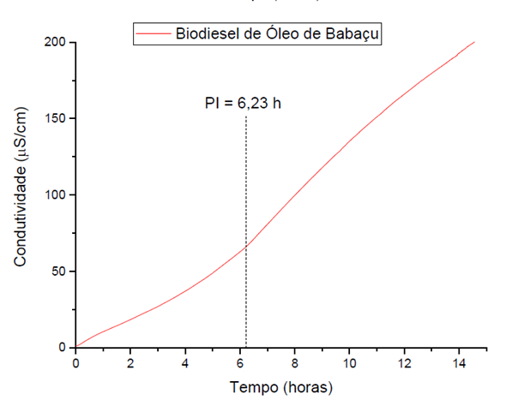
Source: Authoral

Figure 2. BACB sample Rancimat test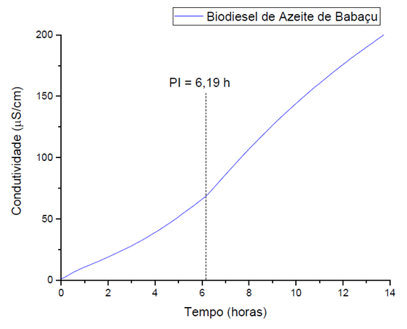
Source: Authoral
By analysing BOCB and BACB, the Rancimat curves of the samples our results demonstrate that both are out of the parameters stablished by ANP 798/2019, which determines minimum of 12 h, being the samples BOCB and BACB pure and free of antioxidants, which may have affected the results.
However, ANP 45/2014 establishes values between 6 and 8 hours, with BOCB and BACB samples within such parameters, even if they are free of antioxidants, demonstrating potentiality in their use in diesel cycle engines.

Conclusions
It is concluded that the bio-diesel proved to be suitable for the production of biodiesel, according to ANP 45/2014.
Acknowledgements
The authors thank Atareco, CNPq, Fapema, and IFCE campus Maracanaú.
References
- DEMIRBAS, A. Biodiesel production from vegetable oils by supercritical methanol. Progress in Energy and Combustion Science, v. 64, p. 858–65, 2005.
- Key world energy statistics, International Energy Agency; 2016.
- GUMUS, M.; KASIFOGLU, S. Performance and emission evaluation of a compression ignition engine using a biodiesel (apricot seed kernel oil methyl ester) and its blends with diesel fuel. Biomass Bioenergy, v. 34, n. 1, p. 134–139, jan. 2010.
- AZAD, A. K.; RASUL, M. G.; KHAN, M. M. K.; SHARMA, S. C.; HAZRAT, M. A. Prospect of biofuels as na alternative transport fuel in Australia. Renewable and Sustainable Energy Reviews, v. 43, p. 331–351, mar. 2015.
- BHUIYA, M. M. K.; RASUL, M. G.; KHAN, M. M. K.; ASHWATH, N.; AZAD, A. K.; MOFIJUR, M. Optimisation of oil extraction process from Australian native beauty leaf seed (Calophyllum inophyllum). Energy Procedia, v. 75, p. 56–61, aug. 2015.
- EMMERICH, F. G.; LUENGO, C. A. Babassu charcoal: A sulfurless renewable thermo-reducing feedstock for steelmaking. Biomass and Bioenergy, v.10, n. 1, p. 41–44, 1996.
- BRASIL. Agência Nacional do Petróleo, Gás Natural e Biocombustíveis - ANP. Resolução ANP nº 798, de 1 de agosto de 2019. Diário Oficial da União, Brasília, DF, 2 ago. 2019.
- BRASIL. Agência Nacional do Petróleo, Gás Natural e Biocombustíveis – ANP. Resolução ANP nº 45, de 25 de agosto de 2014. Diário Oficial da União, Brasília, DF, 26 ago. 2014.

Federal Institute of Maranhão, Imperatriz, Maranhão, joaoneto.eng2018@gmail.com; 2 Polytechnic of Coimbra, ESTeSC, DCBL. Coimbra, Coimbra;
³ University of Coimbra, Coimbra Institute for Clinical and Biomedical Research (iCBR) area of Environment Genetics and Oncobiology (CIMAGO), Biophysics Institute of Faculty of Medicine, Coimbra, Portugal;
⁴ University of Coimbra, Center for Innovative Biomedicine and Biotechnology (CIBB), Coimbra, Portugal;
⁵ Clinical Academic Center of Coimbra (CACC), Coimbra, Portugal;
⁶ Taquari Valley University, Lajeado, Rio Grande do Sul.

